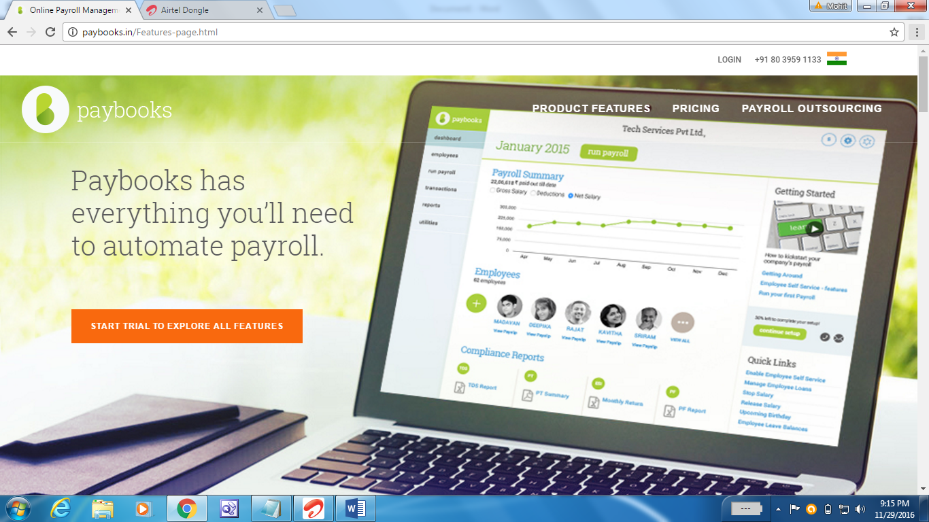

<https://sixmonthtraining.wordpress.com/category/payroll-management-system/>

http://www.slideshare.net/DheerajJha3/payroll-management-system-39274782